Lecture (Cookies + Results + Real API Thinking)
Learning Outcomes (Tell students)
By the end of this session, you should be able to:
- Explain stateless HTTP
- Use cookies to store user info
- Understand HttpContext
- Use Results for proper API responses
- Build a simple login system

🔵 Part 1 — The Problem (10 min)
Ask students:
“If I login, how does the website remember me?”
Explain: HTTP is stateless
👉 Every request is independent
👉 Server forgets everything
Cookies
Cookie = small data stored in browser
Flow:
Server → sends cookie → Browser stores → Browser sends it back
Demo Code:
context.Response.Cookies.Append("username", "Ali");

var user = context.Request.Cookies["username"];

HttpContext
HttpContext = everything about the current request
Split:
Part | Meaning
Request | data from client
Response | data to client

HttpContext is Needed for:
- Cookies
- Headers
- Advanced control
Model Binding and HttpContext
(HttpContext context, LoginRequest request)
Explain:
Item | Purpose
request | JSON → object
context | cookies + HTTP

👉 Golden Rule:
request = data
context = behavior

Understanding Results in ASP.NET Core
📌 What is Results?
In ASP.NET Core Minimal API, we use Results to send responses to the client.
Results = how API responds

👉 It helps us:
- Set the status code
- Return data (JSON)
- Handle success and errors

return Results.Ok("Hello");
return Results.BadRequest("Error");
Method | Meaning
Ok() | success
BadRequest() | client error
NotFound() | missing
Unauthorized() | not allowed

🔹 Common Types of Results
✅ Success Response
// Return success with data
return Results.Ok(new
{
Status = "Success",
Message = "Operation completed"
});
👉 Status Code: 200 OK

❌ Error Response
// Return error response
return Results.BadRequest(new
{
Status = "Error",
Message = "Invalid input"
});
👉 Status Code: 400 Bad Request

🚫 Not Found
// Resource not found
return Results.NotFound("User not found");
👉 Status Code: 404 Not Found

🔒 Unauthorized
// User is not allowed
return Results.Unauthorized();
👉 Status Code: 401 Unauthorized

🔹 Why do we use Results?
Without Results, we cannot clearly control:
- Status code
- Error handling
- API structure
👉 Results makes APIs professional and structured

Summary
👉 “Model Binding = reading data”
👉 “HttpContext = accessing HTTP details”
👉 “Results = sending response”
Concept Map (Very Important Summary)
JSON → Model Binding → request object
Cookies → HttpContext → browser memory
Response → Results → client output
“Cookie = small memory stored in browser”
“Server writes → browser keeps → browser sends back automatically”
the response becomes a JavaScript object .then(res => res.json())
data is the response from the backend (API) after converting it from JSON.
.then(data => {
document.getElementById("result").innerText = data.message;
});
data = whole object
message = one property inside it
HttpContext represents the current HTTP request and response

Simple Login Full System Flow
Login → store cookie → request profile → read cookie → logout → delete cookie
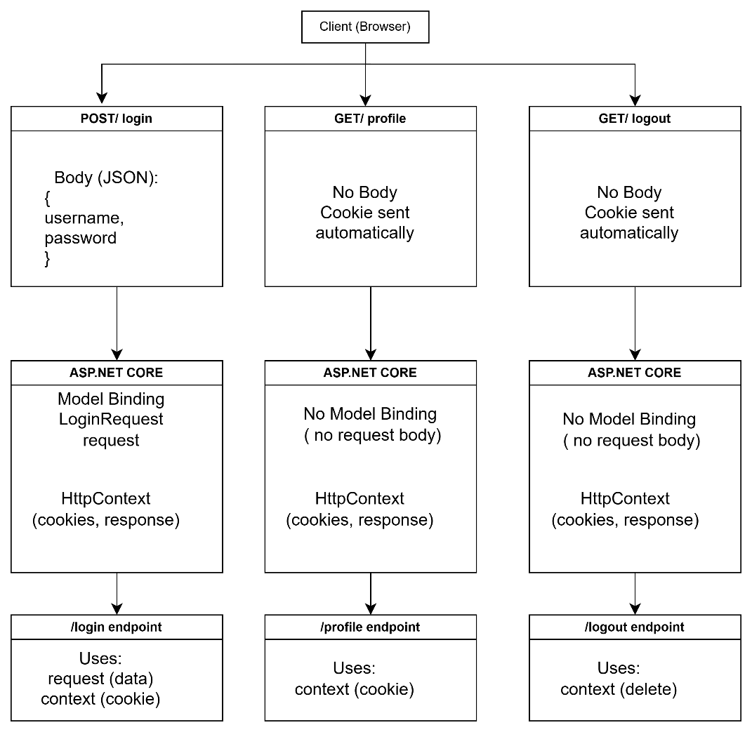
Students must build:
1. Login
- POST request
- Validate username/password
- Store cookie

2. Profile
- Read cookie
- Show welcome message

3. Logout
- Delete cookie

4. Use Results
All endpoints must return:
{ "status": "...",
"message": "..."
}

